

|  |
| --- |
| CUSTOMER 360 |
|  |
| July 3 |

Table of Contents

1. Project Overview
2. Analysis Model
   1. Customer 360
   2. RFM Metrics
3. Customer Segmentation Analysis
   1. Data
   2. RFM Calculation
   3. Customer Segmentation Analysis
4. Findings

Project Overview

* Using Customer 360 concept and RFM analysis method to categorize customers into different groups, helps the marketing team create effective strategies corresponding to each group of customers.

Analysis Model

1. Customer 360

* The Customer 360 view is a comprehensive approach to understanding customers by aggregating data from multiple touchpoints and channels to create a unified and holistic view of each customer. Generally, the customer 360 includes:
  + Demographic Data: basic information about customers such as age, gender, location, etc.
  + Transaction Data: details of past transactions, including purchase history, order value, frequency of purchase, etc.
  + Interaction Data: customer interactions with the company’s various departments, such as sales, marketing, customer service, etc.
  + Behavioral Data: data about customers’ preferences, opinions, need, etc.

1. RFM Metrics

* RFM stands for Recency, Frequency, and Monetary. RFM Analysis is a customer segmentation technique used in marketing to categorize customers based on their purchasing behavior
  + Recency: How recently or the last time the customer has made a purchase
  + Frequency: How often the customer makes a purchase
  + Monetary: Total amount of money the customer has spent
* This report will also measure based on these three components (Recency, Frequency, Monetary) with a scale of 1 to 4 (4 is the highest)

Customer Segmentation Analysis

1. Data

* Analyze on 114,081 active customers within 3 months from 01/06/2022 to 01/09/2022
* Tables:
  + Customer_registered
  + Customer_transaction

1. RFM Calculation

* Recency = datediff(max(purchased_date), ‘2022-09-01’), the last day since a customer made a purchase, compared to ‘2022-09-01’
* Frequency = count(distinct(purchase_date))/contract_age
* Monetary = sum(gmv)

* The interquartile range (IQR) measures the spread of the middle half of your data. It is the range for the middle 50% of your [sample](https://statisticsbyjim.com/glossary/sample/).
* Using IQR method, RFM score is calculated as below:

|  |  |  |  |  |
| --- | --- | --- | --- | --- |
|  | 1 | 2 | 3 | 4 |
| R | 0-31 days | 31-62 days | 62-92 days | 92 days |
| F | 0-0.0005 times | 0.0006-0.0007 times | 0.0005-0.0006 times | 0.0007-0.004  times |
| M | 0-75,000 VND | 75,000-85,000 VND | 85,000-105,000 VND | 105,000-568,182 VND |

1. Customer Segmentation

* Based on the BCG matrix, customers are divided into 4 groups:
  + Star (VIP): Customers who have a high engagement and spend the most
  + Question mark (Potential): Customers who have a high engagement but don’t spend too much.
  + Cash Cow (Loyal): Customers who have a low engagement but have a big bmv
  + Dogs (About to sleep): Customers who have a low engagement and low spending
* Applied into the data:

|  |  |  |
| --- | --- | --- |
| Customer Segmentation | Description | RFM Score |
| Star | Customers frequently visit the website, make purchase, and spend the most money | 443 |
| Question Marks | Customers frequently visit the website, but spend less or don’t make any purchase | 421, 422, 432, 332, 342, 442, 343, 333 |
| Cash Cow | Customers less visit the website, but make purchase and spend money as much as the VIP | 233, 344, 214, 114, 124, 144 |
| Dogs | Customers rarely visit and make the least purchase | 211, 121, 232 |

Findings

* There are 114,080 customers, who spent a total GMV of approximately 11 billion VND

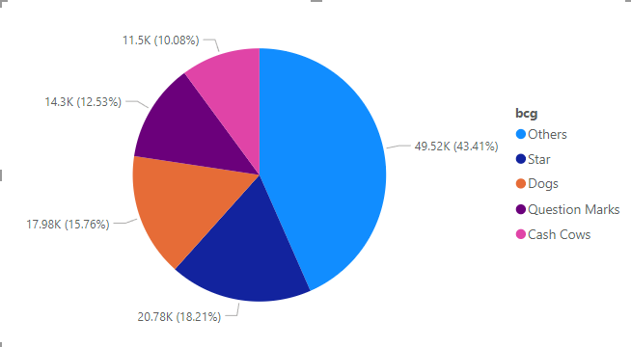

* Among the four segments (excluding the ‘others’ segment), the star segment is the largest (18.21%). This shows that the company’s marketing strategy is well-executed since it attracted a large amount of ‘star’ customers. In addition, the company should also do more research about customers in the ‘others’ segment since it is the biggest segment. The third place goes to dogs segment, followed by question marks, and cash cows segment.

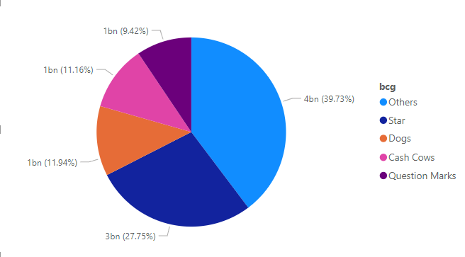

* Similar to the pie chart above in which customers in ‘others’ segment is the largest segment, this pie chart shows that those customers also contribute to the revenue of the company a considerable amount of 4 billion. Follow up is the customers from the ‘star’ segment with 27.75% of the total revenue.

* Suprisingly, customers in ‘star’ segment spent the largest average amount of money. Despite being the largest segment in the other chart, the ‘others’ segment placed third in the average amount of money spent.